- Execute file /etc/passwd to identify the file type.
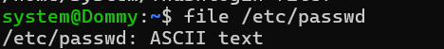
- Execute stat /etc/hostname to view file metadata and permissions.
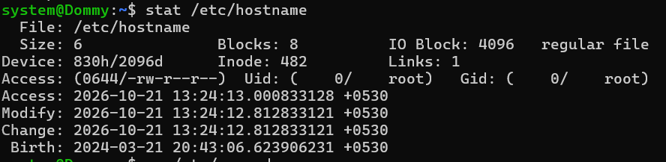
- Execute wc /etc/passwd to count lines, words, and bytes.
- Execute cut -d: -f1 /etc/passwd to extract usernames.
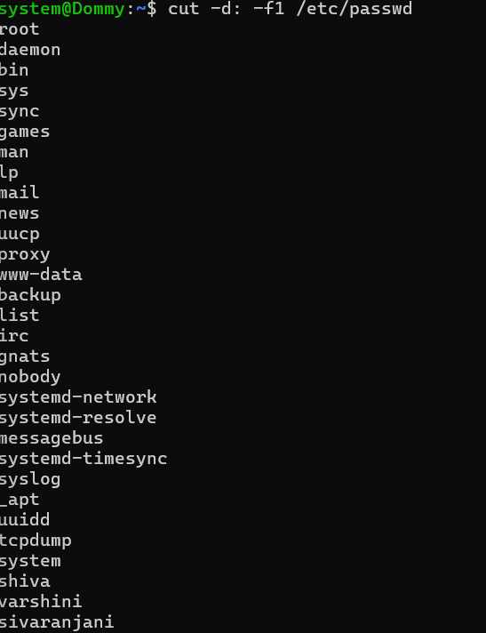
- Execute echo "linux practical" | tr 'a-z' 'A-Z' to convert lowercase text to uppercase.
- Execute echo "Linux practice" | tee practice.txt to display and save text to a file.
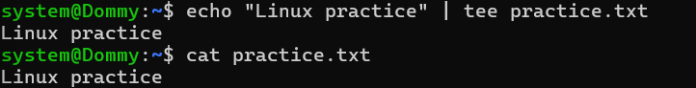
- Execute diff file1.txt file2.txt to compare the contents of two files.
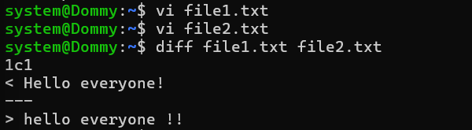
- Execute du -sh ~ to check the disk usage of the home directory.
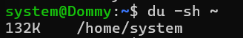
- Execute which bash to locate the Bash executable.
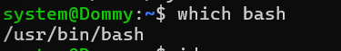
- Execute id to view the current user's ID and group information.
